**Screen shots:**

1. ASP.NET Project:
2. Database PizzaDB:

1. Home Page:

1. List of Pizza Page (Pizza Page):

1. View Order Details (Details Page):

1. Order Confirmation Page:

1. Testing using Selenium:

1. NUnit Testing:

1. Run Test1:

1. Run Test2:

1. Run Test3:

1. Run Test4: (test failed due to mismatch)

1. Run Test5:

1. Results of all test cases:

1. VM in Azure: (ProjectVM created in Azure)

1. Jenkins

🡺Jenkins successfully installed in VM

🡺Jenkins connected to server

🡺Jenkins’s dashboard!

🡺Testing dotnet and java version

🡺Phase 4 Project (Joe’s Pizza Site) is successfully built in Jenkins using GIT.

🡺Its console output!

1. Deployment of ASP.NET project in Azure using app services

🡺New app service is created in Azure Cloud

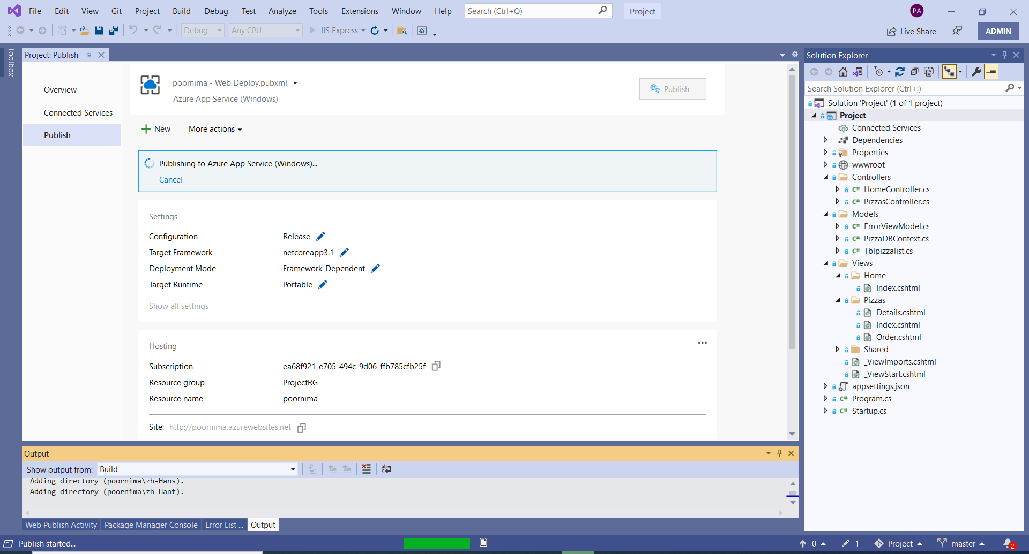🡺Publishing on progress…

The Project got published successfully and its deployed on Azure!

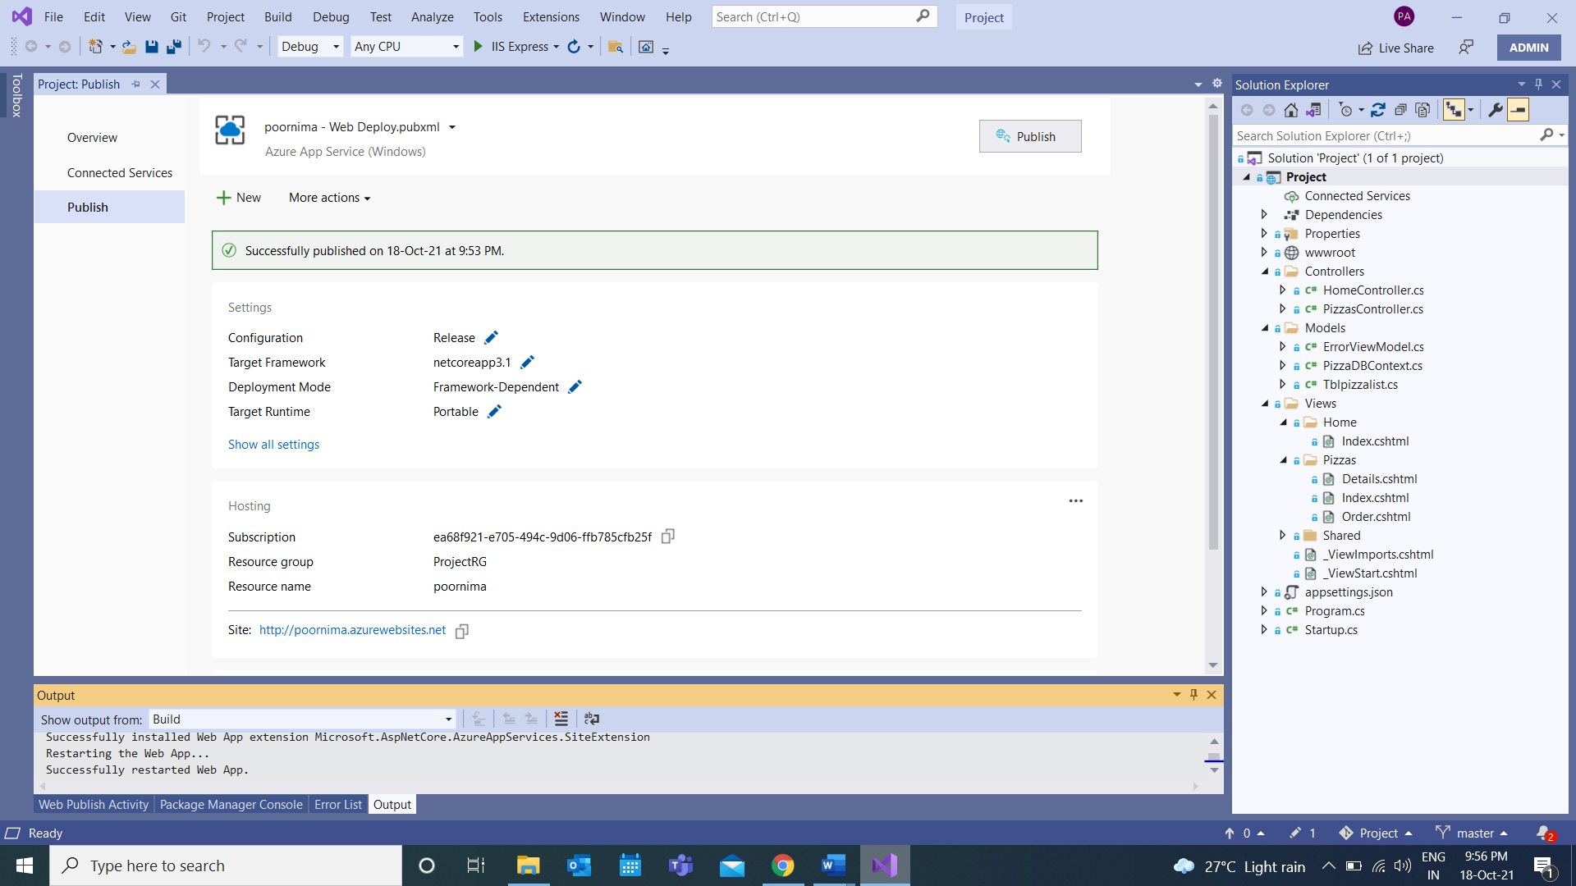

Link: <http://poornima.azurewebsites.net>